**Normalisation Exercises**

The following 2 examples are form-based normalisation exercise; normalise each document, and build an entity model from each.

1. *STUDENT PROGRESS REPORT*

|  |  |  |  |  |
| --- | --- | --- | --- | --- |
|  |  |  |  |  |
| **STUDENT NO.** | **12345** |  | **NAME** | **J Smith** |
| **COURSE** | **Computer Studies** |  | **NATIONALITY** | **UK** |
| **COURSE CODE** | **G400** |  | **TUTOR GROUP** | **2R** |
| **UNIT** | **TITLE** | **UNIT LEADER** | **UL PHONE** | **GRADE** |
| CM5200 | Databases | A Bright | 1234 | A |
| CM4201 | Information Systems | J White | 5678 | B |
| CM5201 | Web Systems | B Adam | 1234 | C |
| CM5302 | Distributed Systems | A Bright | 1234 | B |
|  |  |  |  |  |

**0NF:** STUDENTNO, COURSE, COURSECODE, NAME, NATIONALITY, TUTORGROUP, UNIT, TITLE, UNITLEADER, ULPHONE, GRADE

**1NF:**

Duplicate Data: STUDENTNO, COURSE, COURSECODE, NAME, NATIONALITY, TUTORGROUP

Repeating Attributes: STUDENTNO*, UNIT, TITLE, UNITLEADER, ULPHONE, GRADE

**2NF:**

STUDENTNO, COURSE, COURSECODE, NAME, NATIONALITY, TUTORGROUP

STUDENTNO*, UNIT*, GRADE

UNIT, TITLE, UNITLEADER, ULPHONE

**3NF:**

STUDENTNO, COURSECODE*, NAME, NATIONALITY, TUTORGROUP

COURSECODE, COURSE

STUDENTNO*, UNIT*, GRADE

UNIT, TITLE, ULPHONE

UNITLEADER*, ULPHONE

2. *PLACEMENT INTERVIEW SCHEDULE*

|  |  |  |  |  |  |  |
| --- | --- | --- | --- | --- | --- | --- |
| **VACANCY NO.** | | | **932** |  |  |  |
|  | |  |  |  |  |  |
| **VACANCY** | |  | **Web Designer** | **No. of Posts** | **5** |  |
| **SALARY** | |  | **12000** |  |  |  |
|  | |  |  |  |  |  |
| **EMPLOYER NO.** | | | **467** | **NAME** | **Churchill Engineering plc** |  |
|  |  | |  | **ADDRESS** | **Imperial Way** |  |
|  |  | |  |  | **Doncaster S56 3PX** |  |
|  |  | |  |  |  |  |
| **Date** | **Time** | | **Student Name**  **No** | **Attend (Y/N)** | **Outcome** | **Yr Tutor** |
| 12/02/05 | 11.00 | | 36576 J. Hazel | Y | Offered | A.Brown |
| 13/05/05 | 12.00 | | 26780 K. Hing | Y | Pending | M.Rimms |
| 10/01/05 | 13.00 | | 27719 C. Patel | N | Reschedule | A.Brown |
|  |  | |  |  |  |  |
|  |  | |  |  |  |  |
|  |  | |  |  |  |  |

**0NF:** VacancyNo, Vacancy, Salary, EmployerNo, NoOfPosts, CompName, CompAddress, Date, time, StudentNo, StudentName, Attend, Outcomes, YrTutor

**1NF:** VacancyNo, Vacancy, Salary, EmployerNo, NoOfPosts, CompName, CompAddress

VacancyNo*, Date, Time, StudentNo, StudentName, Attend, Outcome, YrTutor

**2NF:** VacancyNo, Vacancy, Salary, EmployerNo, NoOfPosts, CompName, CompAddress

StudentNo, StudentName, YrTutor

VacancyNo*, StudentNo*, Date, Time, Attend, Outcome

**3NF:** VacancyNo, EmployerNo, NoOfPosts, CompName*, Vacancy*

CompName, CompAddress

Vacancy, Salary

StudentName, YrTutor

StudentNo, StudentName*

Vacancy*, StudentNo*, Date, Time, Attend, Outcome

3. Normalise the following

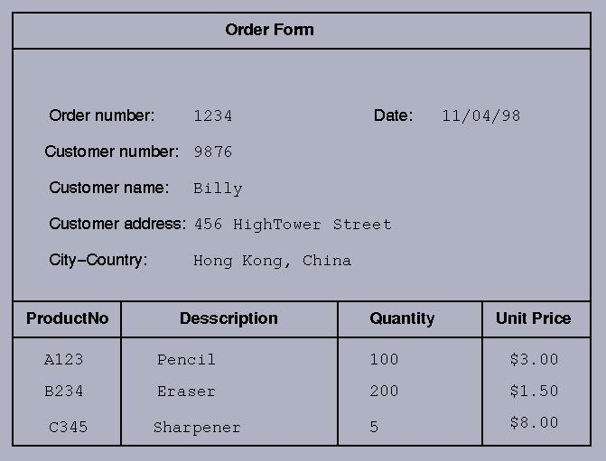

4. The following is an un-normalized PATIENT record:   
(PIDNO, PNAME, FAMDOCNO, DOCNAME, DOCADDR, *(APPTMT-DATE, APPTMT-TIME, CONSULTANT-NAME-CONSULTANT-PHONE, HOSPITAL, HOSPITAL-ADDR)) where * represents repeating groups of information. The business rules are

* On any given day, a consultant attends at just one hospital
* On any given day, a patient will have only one appointment (APPTMT) with a given consultant
* Patient id numbers (PIDNO) and consultant names are unqiue
* Family doctor numbers (FAMDOCNO) and hospital names are unique
* Family doctor names (DOCNAME) and patient names (PNAME) are not unique
* Consultants have just one phone number, used as home base.

5. Given the sample receipt of Wally Vehicle Rentals as shown below, produce the Third Normal Form of this document by normalization.

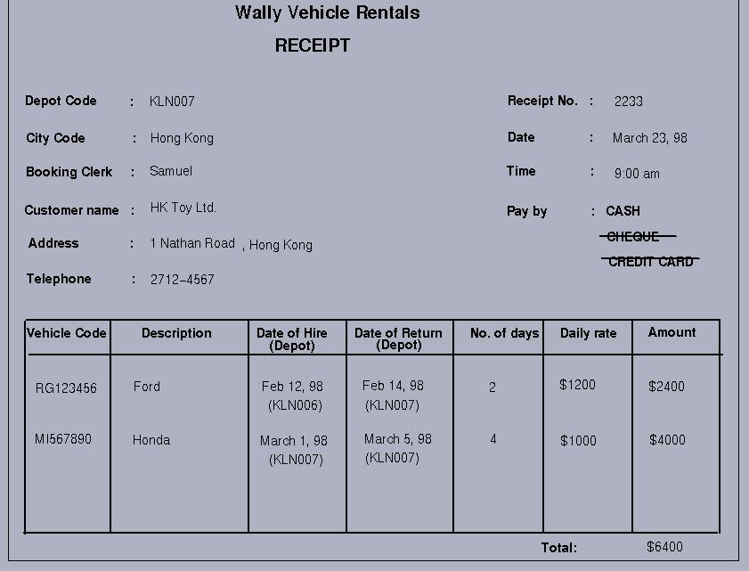

0NF:

DepotCode, CityCode, BookingClerk, CustName, Address, Telephone, ReceiptNo, Date, Time, PayBy, VehicleCode, Description, DateOfHire, DateOfReturn, NoOfDays, DailyRate, Amount

1NF:

DepotCode, CityCode, BookingClerk, CustName, Address, Telephone, ReceiptNo, Date, Time, PayBy

VehicleCode, Description, DateOfHire, DateOfReturn, NoOfDays, DailyRate, Amount

2NF: